EMMANUEL IBORO EKPE
SQL ASSIGNMENT 1

- Create a database called school_management.
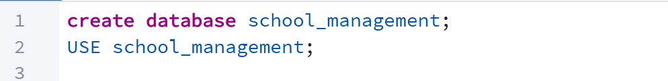
- Create the following tables with appropriate data types and constraints:
  - students (student_id, first_name, last_name, date_of_birth, enrollment_date, major)
  - courses (course_id, course_name, credits, department)
  - instructors (instructor_id, first_name, last_name, hire_date, department)
  - enrollments (enrollment_id, student_id, course_id, semester, year, grade)
Ans 1: 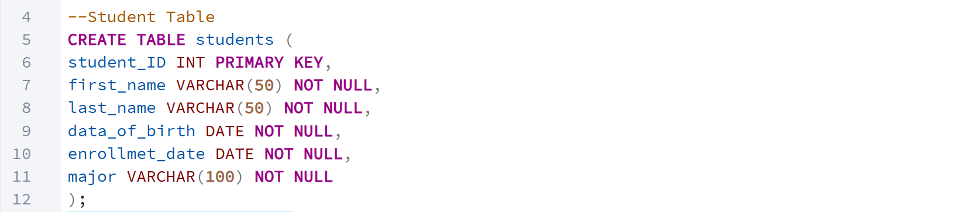
Ans 2: 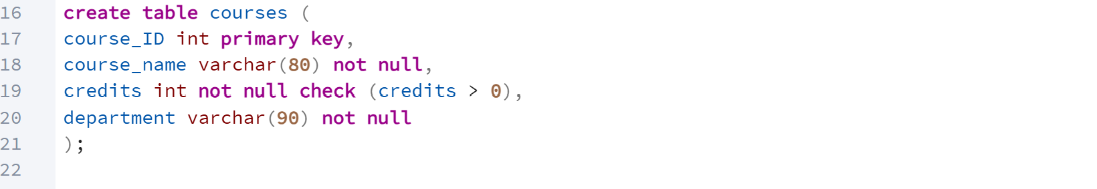
Ans 3: 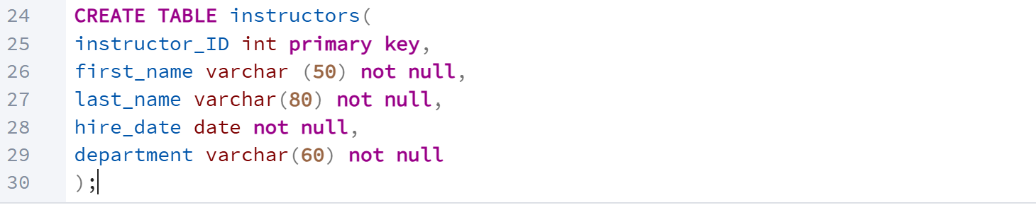
Ans 4: 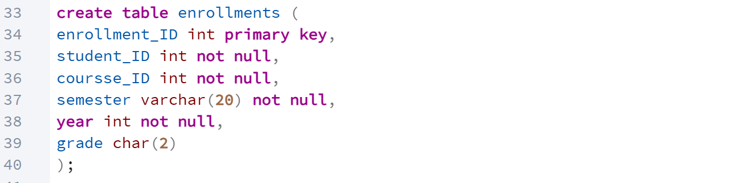
INSERT AT LEAST 10 RECORDS INTO THE STUDENTS TABLE WITH VARIED MAJORS AND ENROLLMENT DATES.

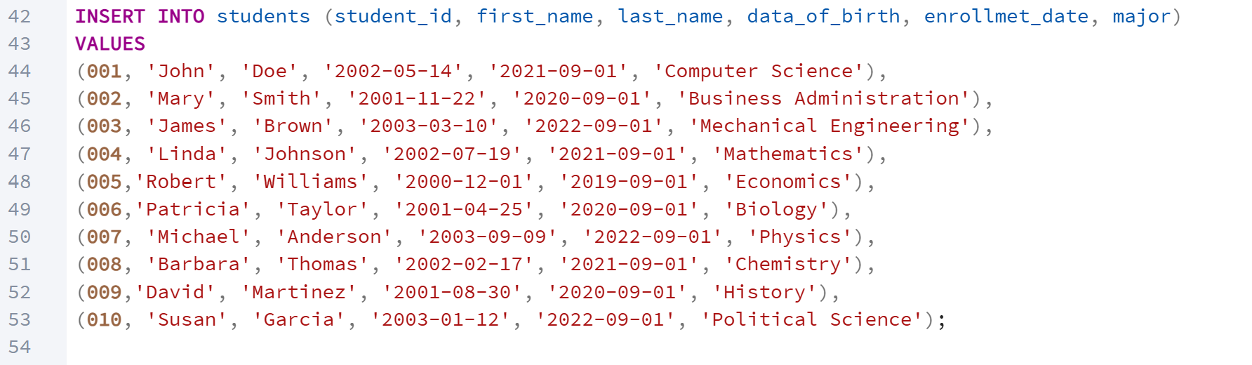

INSERT ATLEAST 8 RECORDS INTO THE COURSES TABLE SPANNING DIFFERENT DEPARTMENTS.
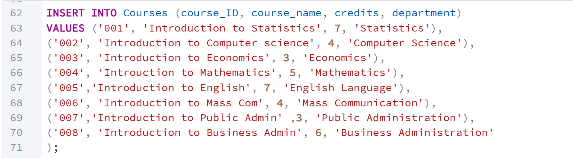

INSERT ATLEAST 5 RECORDS INTO THE INSTRUCTOR’S TABLE
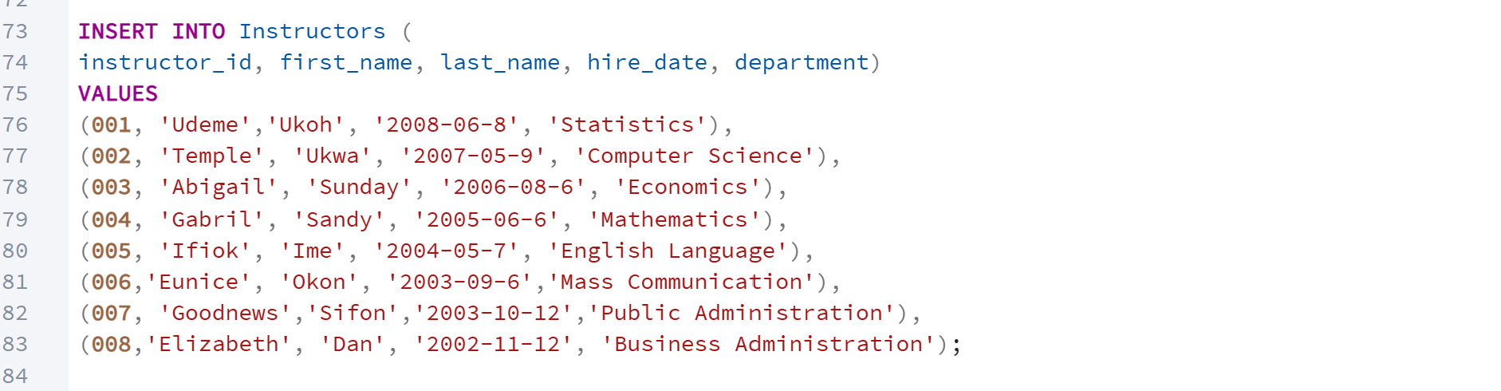

INSERT ATLEAST 20 RECORDS INTO THE ENROLLMENTS TABLE SHOWING DIFFERENT STUDENTS TAKING VARIOUS COURSES.
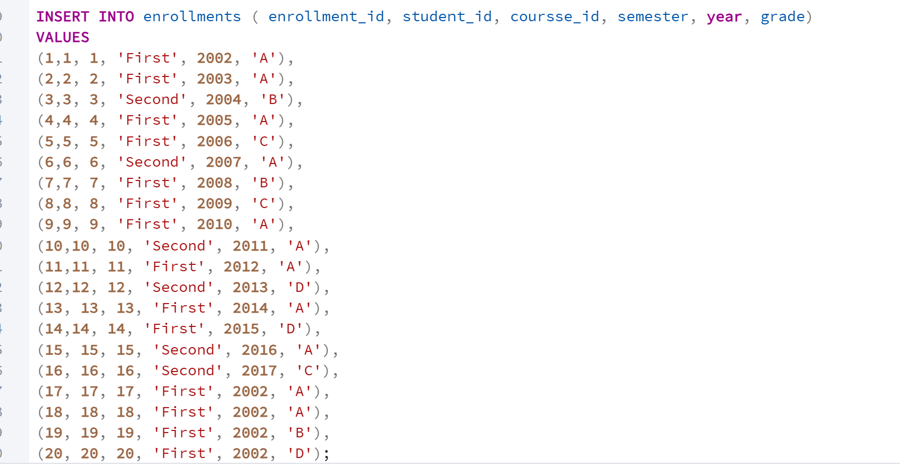

SELECT ALL STUDENTS

FIND ALL COURSES WITH MORE 3 CREDITS
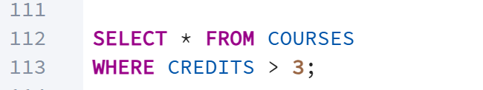

FIND ALL INSTRUCTORS IN A PARTICULAR DEPARTMENT


